**Describe the relation between the financial statements?**

* The income statement describes how the assets and liabilities were used in the stated accounting period
* The cash flow statement explains cash inflows and outflows, and it will ultimately reveal the amount of cash the company has on hand, which is also reported in the balance sheet

**The key points favoring each of these financial statements as being the most important are:**

* Income statement. The most important financial statement for the majority of users is likely to be the income statement, since it reveals the ability of a business to generate a profit. Also, the information listed on the income statement is mostly in relatively current dollars, and so represents a reasonable degree of accuracy. However, it does not reveal the amount of assets and liabilities required to generate a profit, and its results do not necessarily equate to the cash flows generated by the business. Also, the accuracy of this document can be suspect when the [cash basis](http://www.accountingtools.com/questions-and-answers/what-is-the-cash-basis-of-accounting.html) of accounting is used. Thus, the income statement, when used by itself, can be somewhat misleading.
* Balance sheet. The balance sheet is likely to be ranked third by many users, since it does not reveal the results of operations, and some of the numbers listed in it may be based on historical costs, which renders the report less informative. Nonetheless, the balance sheet is of considerable importance when paired with the income statement, since it reveals the amount of investment needed to support the sales and profits shown on the income statement.
* Statement of cash flows. A possible candidate for most important financial statement is the statement of cash flows, because it focuses solely on changes in cash inflows and outflows. This report presents a more clear view of a company's cash flows than the income statement, which can sometimes present skewed results, especially when accruals are mandated under the [accrual basis](http://www.accountingtools.com/definition-accrual-basis) of accounting.

**Another way of looking at the question is which two statements provide the most information? In that case, the best selection is the income statement and balance sheet, since the statement of cash flows can be constructed from these two documents.**

**Yet another variation on the topic is to infer which statement is the most important, based on the perspective of the user. For example:**

* Auditor perspective. Auditors audit the balance sheet, so that is the document that they have the greatest interest in.
* Investor perspective. Investor analysis of share value is largely based on cash flows, so they will have the greatest interest in the statement of cash flows.
* Lawyer perspective. Anyone bringing a lawsuit against a company will want to review its balance sheet first, to see if there are enough assets to attach if the lawsuit is successful. Otherwise, it is not cost-effective to pursue a lawsuit.
* Management perspective. Managers are responsible for fine-tuning the business, so they are likely to delve most deeply into the income statement.

**What can you tell from a Yield Curve?**

* The yield curve represents the relationship between interest rates on bonds of different maturities, but equal credit quality.
* The slope of the yield curve has proven to be a good forecaster of economic growth. There are three basic shapes the yield curve can take, each with different implications regarding economic growth.
* A normal, upward sloping yield curve is shown below. This is how the yield curve looks when an economy is growing and investors are confident. In a growing economy, investors demand additional premium (yield) for longer maturity bonds. This is logical considering there is more risk associated with having money tied up for longer periods of time.

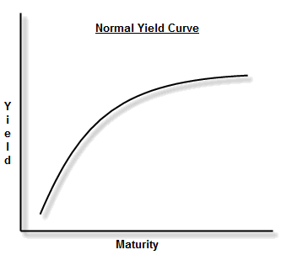

* A flat yield curve indicates that investors are not being compensated for the additional risk of longer maturity bonds. This is a warning sign that an economy is under duress; investors expect slow growth, and economic indicators are sending mixed signals. As investors buy and sell bonds to flatten the yield curve, they are demonstrating through their behavior that they are worried about the outlook of the economy. As a result, they prefer to have their money tied up longer in safe investments, and demand less of a return for doing so.

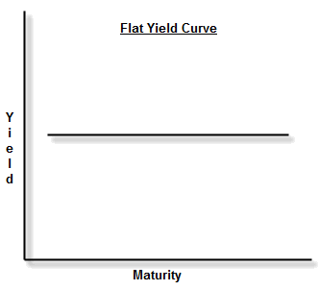

* A flat yield curve can develop into the dreaded "inverted" yield curve when the economic outlook is very bleak. When the yield curve inverts, it indicates tough economic times ahead. The logic goes like this: If I'm worried the economy is going to crash, I want to look for safe ways of preserving my capital. If I suspect falling equity prices, and falling interest rates, I'm going to try to lock my capital away in longer-term bonds as a way to ride out the storm. As more and more investors do this, it drives longer maturity bond prices up, and the yields down. These same investors will shy away from short-term bonds, which may have to be reinvested during the downturn. This lack of demand drives short-term treasury prices down and the yields up.

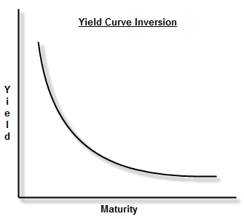

* There are multiple ways to analyze the slope of the yield curve, so which is the most accurate? Statistically, the method that has shown the most reliability in predicting future economic growth has been to look at the difference between the rates on the 10-year Treasury Note and the 3-Month Treasury Bill. When the yield on the 10-year is greater than the yield on the 3-Month, the slope is positive, and when this relationship reverses (3-Month rate greater than the 10-Year rate), the slope is negative and the yield curve is considered inverted. Historical observations using this method show that an inverted yield curve indicates a recession approximately one year away.

**What is a 'Bond'**

* A bond is a debt investment in which an investor loans money to an entity (typically corporate or governmental) which borrows the funds for a defined period of time at a variable or fixed interest rate. Bonds are used by companies, municipalities, states and sovereign governments to raise money and finance a variety of projects and activities.

**Fixed Income**

* An investment that provides a return in the form of fixed periodic [payments](http://www.investopedia.com/terms/p/payment.asp).

**Discount/Premium Bonds**

* A bond currently trading for less than its par value in the secondary market is a **discount bond**. A bond will trade at a discount when it offers a coupon rate that is lower than prevailing interest rates. Since investors always want a higher yield, they will pay less for a bond with a coupon rate lower than the prevailing rates.
* A bond that is trading above its par value in the secondary market is a **premium bond**. A bond will trade at a premium when it offers a coupon (interest) rate that is higher than the current prevailing interest rates being offered for new bonds. This is because investors want a higher yield, which such a bond gives them, and thus they will pay more for it.

**Describe the various valuation techniques and how would you go about valuing a specific building?**

* **Comparable Company Analysis (Public Comps):**Evaluating other, similar companies’ current valuation metrics, determined by market prices, and applying them to the company being valued.
* **Discounted Cash Flow Analysis (DCF):**Valuing a company by projecting its future cash flows and then using the Net Present Value (NPV) method to value the firm.
* **Regression Model**

**Greeks Finance**

* Delta measures the rate of change of the theoretical option value with respect to changes in the underlying asset's price. Delta is the [first derivative](https://en.wikipedia.org/wiki/Partial_derivative) of the value https://upload.wikimedia.org/math/5/2/0/5206560a306a2e085a437fd258eb57ce.png of the option with respect to the underlying instrument's price https://upload.wikimedia.org/math/5/d/b/5dbc98dcc983a70728bd082d1a47546e.png.
* Vega measures sensitivity to [volatility](https://en.wikipedia.org/wiki/Volatility_(finance)). Vega is the derivative of the option value with respect to the [volatility](https://en.wikipedia.org/wiki/Volatility_(finance)) of the underlying asset.
* Theta Theta, measures the sensitivity of the value of the derivative to the passage of time (see [Option time value](https://en.wikipedia.org/wiki/Option_time_value)): the "time decay."
* Rho rho, measures sensitivity to the interest rate: it is the derivative of the option value with respect to the risk free interest rate (for the relevant outstanding term).
* Lambda lambda, Omega Omega, or elasticity is the [percentage](https://en.wikipedia.org/wiki/Percentage) change in option value per [percentage](https://en.wikipedia.org/wiki/Percentage) change in the underlying price, a measure of [leverage](https://en.wikipedia.org/wiki/Leverage_(finance)), sometimes called gearing.
* Gamma Gamma, measures the rate of change in the delta with respect to changes in the underlying price. Gamma is the second derivative of the value function with respect to the underlying price. All long options have positive gamma and all short options have negative gamma.

**Question to Ask**

* What does company value the most, how can I work further these values?
* What kinds of process are in place to help me work collaboratively?
* What can you tell me about this job that isn't in the description?
* What are the prospects for growth for the person in this job?
* How do you measure success in this job? By the organization?
* What is the key to success in this organization?
* How many people are in this group (department, office, and/or company)?
* What do you enjoy most about working here?
* When will you be back in touch with me?

**My greatest strength**

* Self starter
* Quick learner
* Able to adapt different environment quickly

**Why working for Prudential**

This is the field I am interesting in; I’ve always wanted to work in the capital side as well as investment side of the company, and I know Prudential has great reputation in the industry. It values its employees and gives them the opportunity to growth with the company.